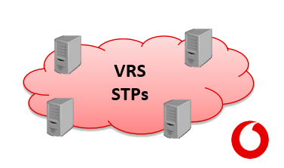

v1.0.0.0

Vodafone roaming services engineering tool

**VRS Engineering Tool**

**User Manual**

# Table of Contents

* Table of Contents 1
* Introduction 2
* Prerequisites 2
* Overall Application View 3

User Interface 3

Loaded Data 4

Menu interface 5

* Advanced Search 7

Search Types 7

* Operator 9

Romina info 9

STP info 9

NP7 Opened Relationships 10

Documents 10

* Agreements 11
* OST 12
* STP Audit 13

# Introduction

VRS Engineering Tool is an application which its purpose is to facilitate daily tasks to Vodafone Roaming Services engineering team.

# Prerequisites

To be able to run the application, there is a requisite that must be met.

The following software must be present in the computer where the application is going to be installed:

1. **Microsoft .NET Framework 4.5.2**

The installation program itself will notify this when being executed and will offer the possibility to perform its installation as well.

# Overall Application View

## User Interface

Once the application is launched, the following window will be displayed.

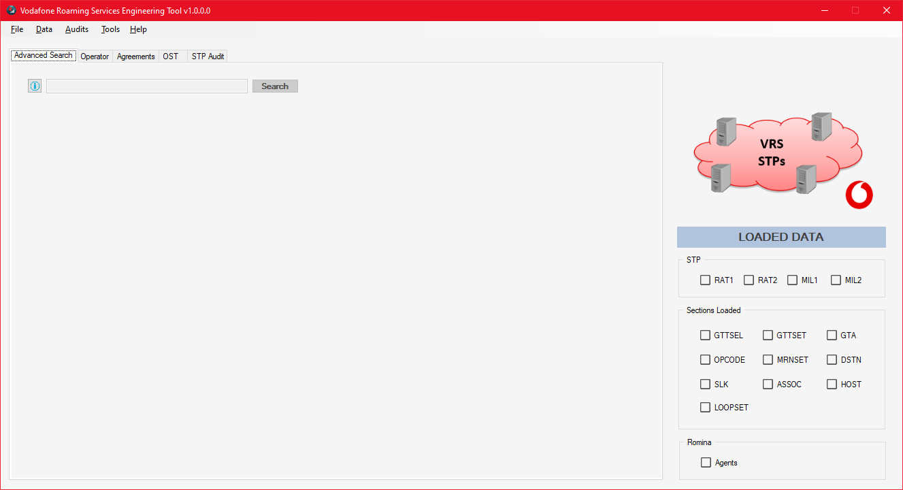

To work with the application, data must be loaded (STPs, Romina or Confluence).

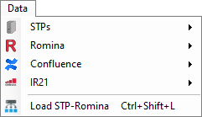

Once and depending on loaded data we can perform several actions:

* **Advanced Search**

This section provides de ability to obtain Romina Agents information offline.

* **Operator**

This section provides both Romina Agents and OST information depending on loaded data associated to a searched operator.

* **Agreements**
* OST
* STP Audit
* Audits

## Loaded Data

As data is loaded, this section will reflect which type is stored in memory to work with.

## Menu interface

The application menu will let us perform several actions.

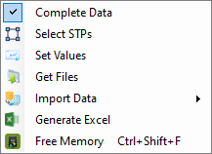

Determines if all data included in source files will be loaded

Selects STPs from which data will be loaded

Generates Excel with all STPs loaded data

Loads Romina and all STPs data

Frees memory by removing STPs loaded data

Loads all or each specific module data in memory

SFTP values needed to obtain source files of OST from Eagle STPs

User and Password of user to connect to machine with source files by SFTP

Loads all or each specific module data in memory

Checks GTA table data in which point codes don’t meet corresponding Loopset.

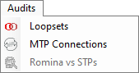

It also provides the chance to generate an Excel file with the results.

Under Tools section we have an SS7 Point Code Coverter to translate point codes from decimal to 14 bit (8-3-8):

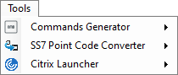



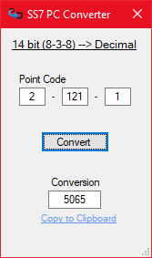Decimal 🡪 14 bit 14 bit 🡪 Decimal

# Advanced Search

This section provides de ability to obtain **Romina Agents** information offline by using certain keywords in the search textbox *(Romina data needs to be loaded)*.

Search query typed in textbox

Number of elements found with query

## Search Types

* **Generic**

Any agent whose TSC, MGT, IMSI, or Name contains the typed value.

* **Specific**

Any agent whose TSC, MGT, IMSI, or Name is exactly as typed inside quotes --> (Example "2050").

* **By Field**

Available fields to filter with (both the entire field name or each code can be used):

* + TSC (T)
  + MGT (MG)
  + IMSI (I)
  + NAME (NA)
  + NGT (NG)
  + MSISDN (MS)

**Some examples**

I 214 🡪 Will show any agent that has the imsi containing 214.

IMSI "21401" 🡪 Will show any agent that has imsi 21404.

NA "VF" 🡪 Will show any agent which its name is exactly VF.

**Additional search parameter S**

Both in Generic and By Field searches, we can include **-S** to search info starting with the typed value.

-S 210 🡪 Will meet any agent that has a field that starts with 210.

I -S 210 🡪 Will meet any agent which its IMSI starts with 210.

Once search results are displayed, by selecting one of the results related info will be shown (STP information will also be displayed if OST data is loaded).

In the operator detail sections, by clicking each of the highlighted fields in below image we will copy related info to system clipboard.

Copies both the entire list by clicking MSISDN and a specific value by clicking each one

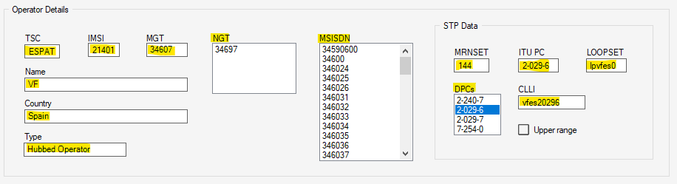

If marked indicates that routing data is related to an upper range that affects operator MGT

# Operator

This section provides Romina (loaded data required) and STP (in case it is loaded) information for an operator searched by either TADIG, MGT or IMSI.



## Graphical user interface, text, application Description automatically generatedRomina info

By clicking each of the highlighted fields related info will be copied to system clipboard.

## STP info

By clicking each of the highlighted fields related info will be copied to system clipboard.

## NP7 Opened Relationships

Numbering Plan 7 relationships opened in STPs both acting as Visited and as Home.

By clicking each of the highlighted fields related info will be copied to system clipboard.

## Documents

Link to corresponding IR21 document PDF and XML files in case they are present in selected documents associated folder path ***(Not working in current version)***.

# Agreements

This section provides the possibility to check if the agreements between two operators are opened in the STPs configuration.

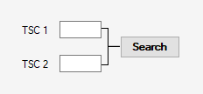

Once operators are defined and search is completed, result will show four possible status:

Opened

Not opened

Existing upper range



Existing subrange configured

# OST

This section provides the ability to check all STPs configurations and to apply desired filters.

With these filters, excel files with specific information can be generated.

Each of the STPs info can be selected in case it has been loaded (only affects current section)

Generates an Excel file with all OST data loaded, taking in consideration any filter applied

Sections with the same colour have some dependencies to show all data values

Clears all filters applied in any section

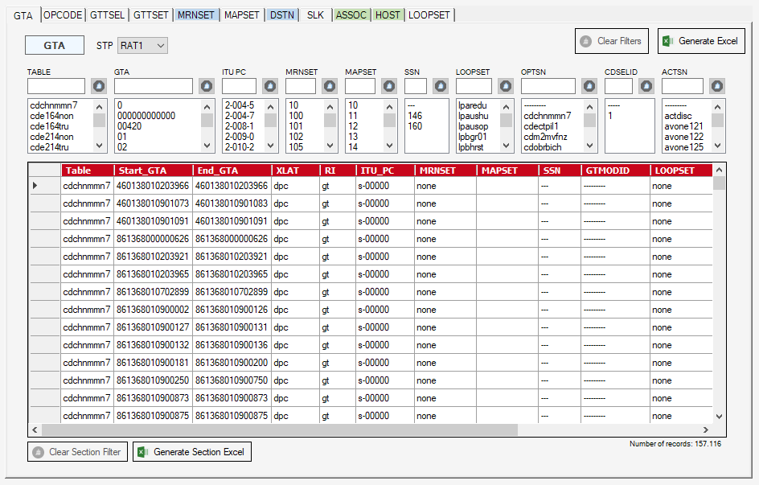

Generates an Excel file with all OST data loaded, taking in consideration any filter applied

Number of records taking in consideration applied filter

Clears filter applied in current section

Generates Excel file with current section taking in consideration applied filter

Number of records taking in consideration applied filter

Textbox filter (with * we can use start with condition)

By clicking each of the headers, all elements in list will copied to the system clipboard

List selection filter

Clears filter

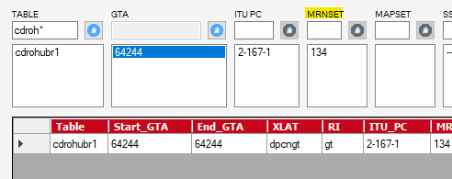

# STP Audit

In this section, different audits of the STPs configuration can be performed, depending on the loaded data.

For this section to be enabled, all STPs data must be loaded.

STP RAT1 will be the node with which the comparisons will be made.

Audit type to be performed (also shows specific audit type results once audit has been performed).

If **All** option is selected, an audit of all loaded modules will be performed.

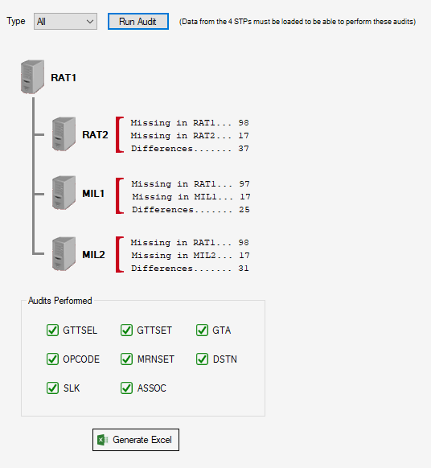

Generates an Excel will all audits result

Once an audit is performed, if a module is selected in type list, we will have the option to generate a specific Excel file with module’s audit results, and to see a slight presentation of those results by clicking each of the STPs audit results sections:

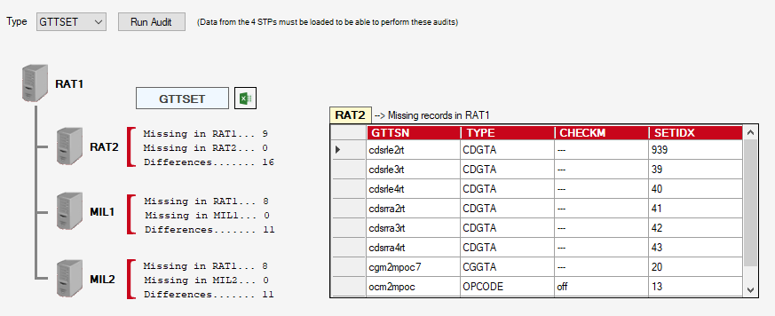

Button to generate Excel file with current module audit results